To let/FOR SALE
DETACHED TWO STOREY OFFICE BUILDING
UNIT 1 HAWTHORN PARK, COAL ROAD, LEEDS, LS14 1PQ
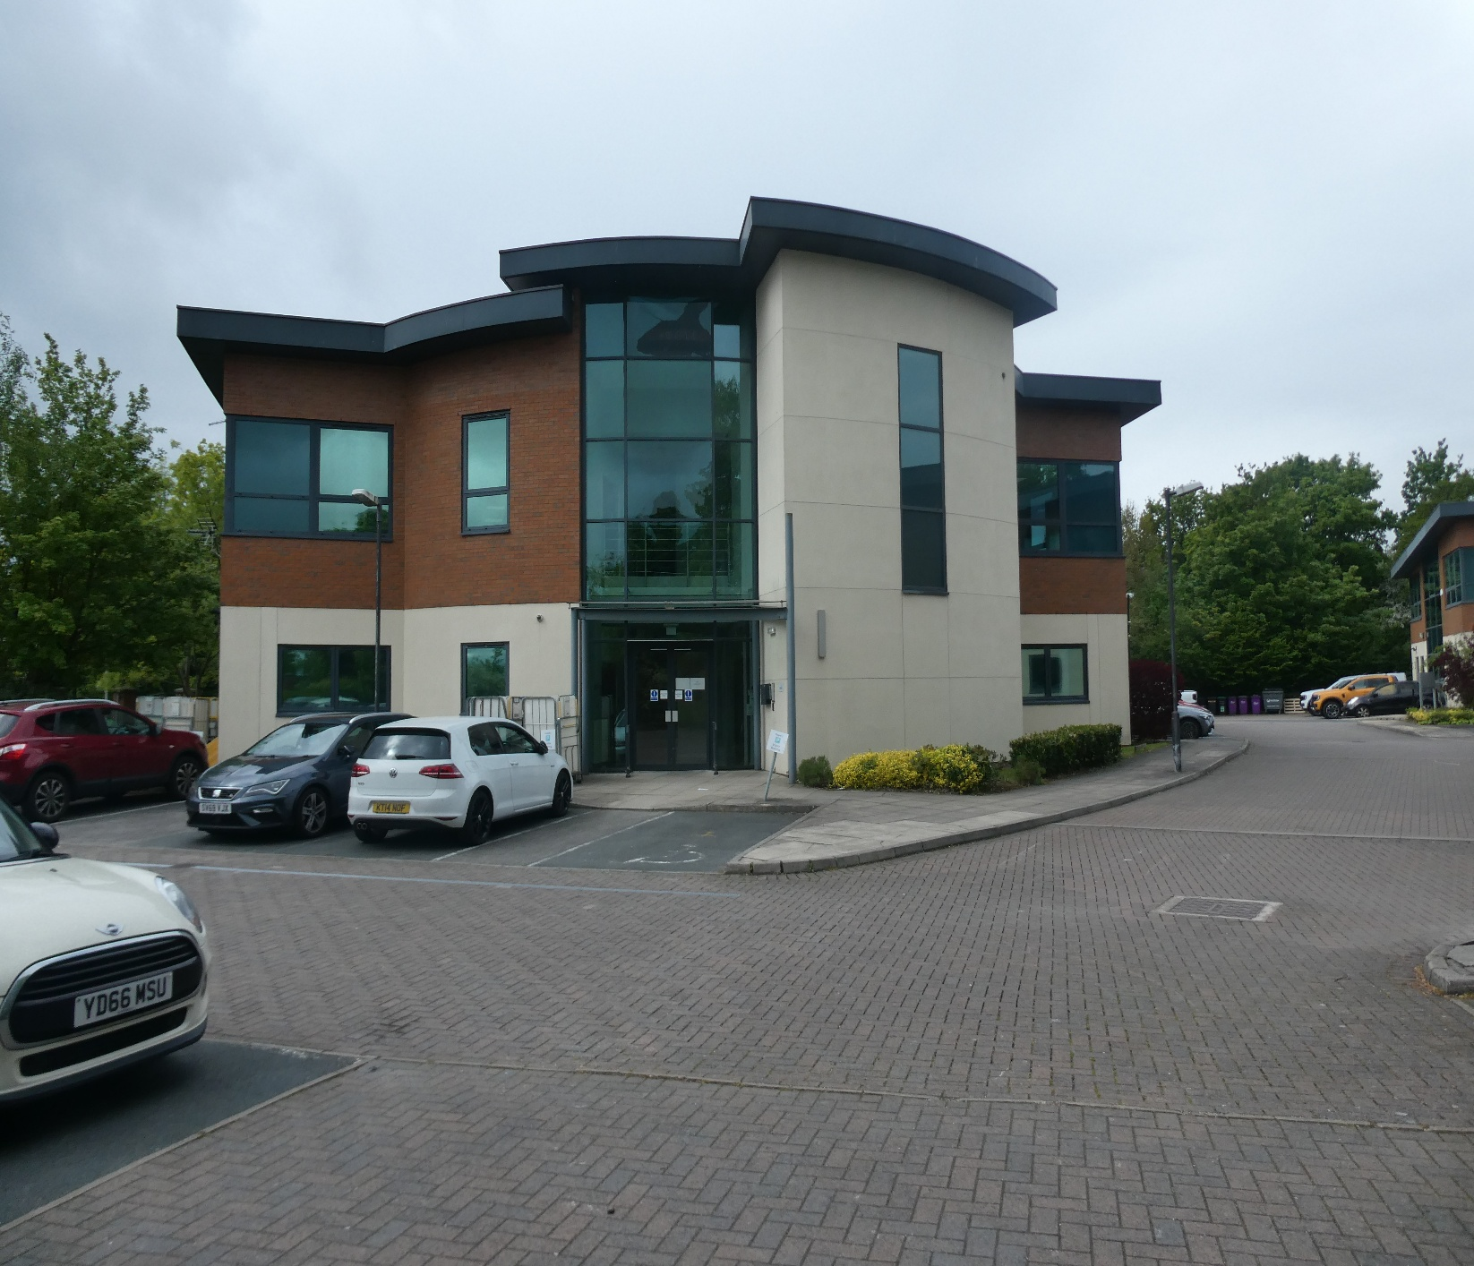
- Popular office park.  - Good sized carpark.  - Fully raised floors.  - Passenger lift. |  | Rental: £85,000 p/a  Freehold: £900,000
631m²
(6,800ft²)

UNIT 1 HAWTHORN PARK, COAL ROAD, LEEDS, LS14 1PQ
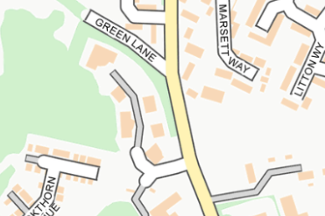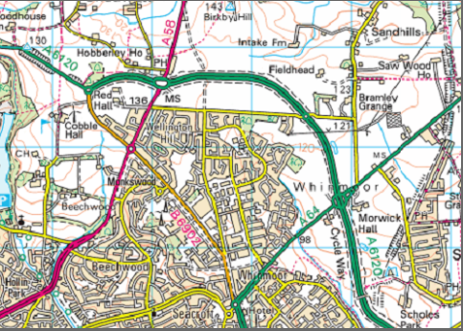

LOCATION  Hawthorn Park is conveniently located on Coal Road, readily accessible for the Leeds Outer Ring Road and the East Leeds Orbital Route. This facilitates easy access to the motorway network. Leeds City Centre is about 6 miles away. Occupiers within the park include Villa Care, Watson Property Management and Trade Skills 4 U.  DESCRIPTION  The building is of traditional construction built around a steel frame with walls faced externally in brick with a part rendered covering and part aluminum and glazed curtain walling under a Sarnafil roof. There are concealed gutters and metal fall pipes. There are 22 car parking spaces together with bin store and cycle store.  ACCOMMODATION  SERVICES  We understand that the property benefits from all mains services. No test of the services has been made, and we cannot comment on their condition. Please note that no service connections or appliances will be tested prior to completion. | RATEABLE VALUE  The property is assessed for rating purposes on the 2006 rating list as follows.  PLANNING  The property has planning consent for office use.  TENURE  The property is leasehold for a term of 999 years from 1st April 2002 at a ground rent of 1 white rose. It is understood that the demise includes the property known as Unit 1 Hawthorn Park, together with the landscaped areas and carparking. There is an annual service charge to cover a contribution towards the landlords’ services.  The property is for sale subject to the 999-year lease or is available to let on a 5-year term (or multiples of 5 years) on full repairing and insuring terms.  TERMS  Rental: £85,000 per annum.  Long Leasehold: £900,000.  VAT  Our client has advised us that Value Added Taxation is applicable on this transaction.  LEGAL COSTS  The tenant will be responsible for the landlords’ legal costs in the preparation of the lease. If the property is sold, each party will be responsible for their own legal costs. | EPC  VIEWING  By appointment only  Nabarro McAllister  0113 266 7666  info@nabarromcallister.co.uk  www.nabarromcallister.co.uk  JUNE 2026
   | m2 | ft2
  GROUND FLOOR
  Entrance Hall with W. C’s and lift
  Ground floor offices | 315.8 | 3,400
  FIRST FLOOR
  Landing area, 2 W. C’s and open plan office space and separate kitchen with gas fired central heating boiler. | 315.8 | 3,400
  TOTAL | 631 | 6,800
  GROUND FLOOR
  Rateable Value (2026) | Estimated rates payable
  £46,000 | £18,400
  FIRST FLOOR
  Rateable Value (2026) | Estimated rates payable
  £45,500 | £17,600
Subject to Contract
The properly is offered subject to contract, availability and conﬁrmation of details. These details are provided by Nabarro McAllister & Co. Ltd only as a general guide to what is being offered and are not intended to be construed as containing and representation of fact upon which any interested party is entitled to rely. Other than this general guide neither Nabarro McAllister & Co. Ltd nor any person in their employ has any authority to make, give or imply any representation or warranty whatsoever relating to the properties in these details. Any intending purchaser/lessee must satisfy themselves by inspection or otherwise as to the correctness of each of the statements contained in these particulars. Third parties must undertake their own enquiries and satisfy themselves in this regard. Unless otherwise states, all prices are quoted exclusive of VAT.
Nabarro McAllister & Co. Ltd. Devonshire Lodge, Devonshire Avenue, Leeds, West Yorkshire, LS8 1AY
© OpenStreetMap contributors

